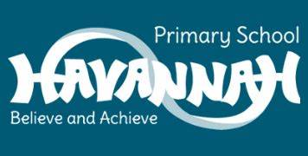
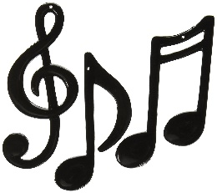
Year 3 Music End Points

- Can I perform to an audience both in unison and cannon?
- Can I add my own ideas to make a piece of music more exciting my adding actions?
- Can I use specialist vocabulary to discuss a piece of music?
- Can I perform creatively and expressively to an audience whilst showing emotion?
- Can I create and compose a short bar of music using learned notation?
- Use prior knowledge of The 8 Elements of Music to discuss changes in music?
- Can I perform creatively and expressively to an audience, using guidance from conductor?
- Can I create and perform a chant to an audience, using knowledge and inspiration from other chants?
- Can I show good listening skills and evaluating skills, using music vocabulary to discuss songs from around the world?
- Can I follow notation on a stave for a song and pick up the tune?
- Can I show an understanding that music is broad and has many different genres?
- Can I describe musical terms such as forte and piano?
- Can I describe musical terms such as pitch, tempo, texture, rhythm, speed?

