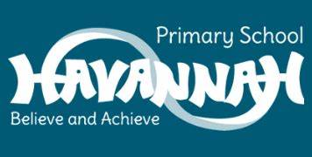
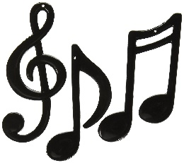
Year 4 Music End Points

- Can I perform creatively and expressively to an audience?
- Can I compose music using notation?
- Can I discuss a range of different music using a range of musically associated vocabulary confidentially?
- Can I perform creatively and expressively to an audience both in canon and unison?
- Can I create my own 16 bar piece on a stave using music notes to represent a mood?
- Can I confidently discuss a live piece of music using specialist vocabulary as well as the likes and dislikes of the song?
- Can I follow instructions from a conductor to create a tune?
- Can I show an improvement from the start to the end of the term when playing my instrument?
- Can I evaluate my own listening skills when listening to a conductor during a lesson?
- Can I show that I can improvise to create a tune?
- Can I evaluate my own performance either singing or playing to an audience and give myself a goal to achieve?
- Can I show that I can explore the 8 elements of music such as rhythm and tempo with my instrument?

