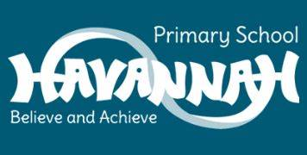
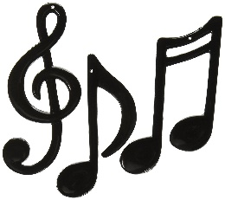
Year 2 Music End Points

- Can I perform to an audience?
- Can I compose using creative ideas and inspiration from pieces of music?
- Can I confidentially write music using notation?
- Can I perform expressively and creatively to an audience?
- Can I confidently discuss how changes in the pitch and tempo of a song can make you feel?
- Can I identify the changes in a song and say what has changed?
- Can I use music terminology to discuss a song?
- Can I create a chant to show a theme whilst using features taught?
- Can evaluate a piece of music using music vocabulary and suggest improvements?
- Can I create an improvised beat?
- Can I recognise the dynamics in a song and explain what it means?
- Can I create a beat using my voice?

