Knowledge Sheet Geography
Stone Age Cycle B KS1
Intent
At Havannah Primary School our intention within Geography, is to develop within our pupils a deep sense of location and place knowledge and supported by map skills and fieldwork.
Our curriculum will nurture a deep sense of inquisitiveness and ingenuity within our pupils and enable children to make connections and transfer skills and knowledge to a variety of learning opportunities. Our uniquely creative curriculum will inspire our pupils, stimulate their curiosity about places and locations and encourage investigation and critical thought.

Key Vocabulary
UK | The United Kingdom made up of England, Scotland, Wales and Northern Ireland
Capital City | A city or town where the government is based for that country
Location | A particular place or position
Compass Points | The four main directions or points on a compass – North, South, East, West.
Atlas | A collection of maps
Stone Age Settlement | A temporary place of shelter where nomadic people stayed and hunted for food.

Key Knowledge
- Name and locate four countries – England, Scotland, Wales, Northern Ireland and capitals – London, Cardiff, Edinburgh, Dublin, of Uk and compare to Stone Age.
- Use maps, globes and atlases to identify countries and capitals – as above.
- Use directional language – Near, Far, Left, Right.
- Use simple compass points – North, South, East and West.
- Name human and physical features of school and human and physical features of a Stone Age camp.

Prior Knowledge
I know where I live (Congleton)
I know Congleton is in England
I can point to England on a map

Map of UK 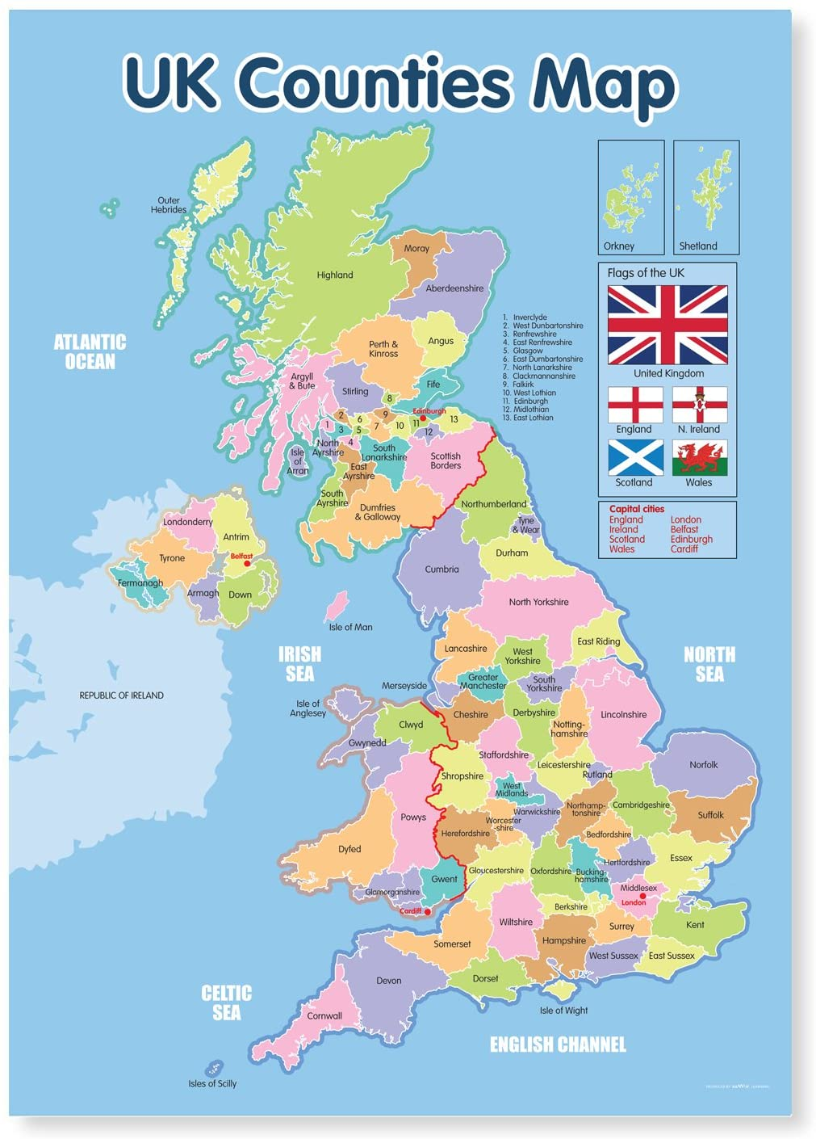
Map of the Europe during Stone Age
