Knowledge Sheet Science Rocks Cycle B LKS2
Intent
At Havannah Primary School, we intend to deliver a Science curriculum that is fully inclusive for every child and instils a curiosity and fascination about the natural and man-made world. Our aims are to provide a high quality, broad, balanced and differentiated curriculum that ensures all children acquire the knowledge and skills to make progress in Science and importantly, it should help the children to develop a love of Science.
Science at Havannah is now taught in the three strands of biology, chemistry and physics. Through different types of scientific enquiry, all of the children will have the opportunity to develop skills when working scientifically and become aware of prominent scientists.

Prior Knowledge
- asking simple questions and recognising that they can be answered in different ways
- observing closely, using simple equipment
- performing simple tests
- identifying and classifying
- using their observations and ideas to suggest answers to questions
- gathering and recording data to help in answering questions

Skills (Working Scientifically)
- Compare and group together different kinds of rocks on the basis of their appearance and simple physical properties
- Observe different types of rocks in and around the local area and the purpose for which they have been used
- Ask questions about why rocks might have changed over time
- Classify and group rocks according to whether they have grains or crystals, and whether they have fossils in them (by using hand lenses or microscopes)
- Ask and answer questions about why soils are formed
Use knowledge gained to make model fossil and then report this to the rest of the class as a display.

Key Vocabulary
Rock
Soil
Grains
Crystals
Fossils
Lenses
Microscope
Sedimentary
Igneous
Metamorphic
Volcanic
Evergreen | Feet leg  Sense  See  Hear  Smell  Touch  Taste

Hands
Feet leg
Sense
See
Hear
Smell
Touch
Taste

Famous Scientists
Charles Darwin
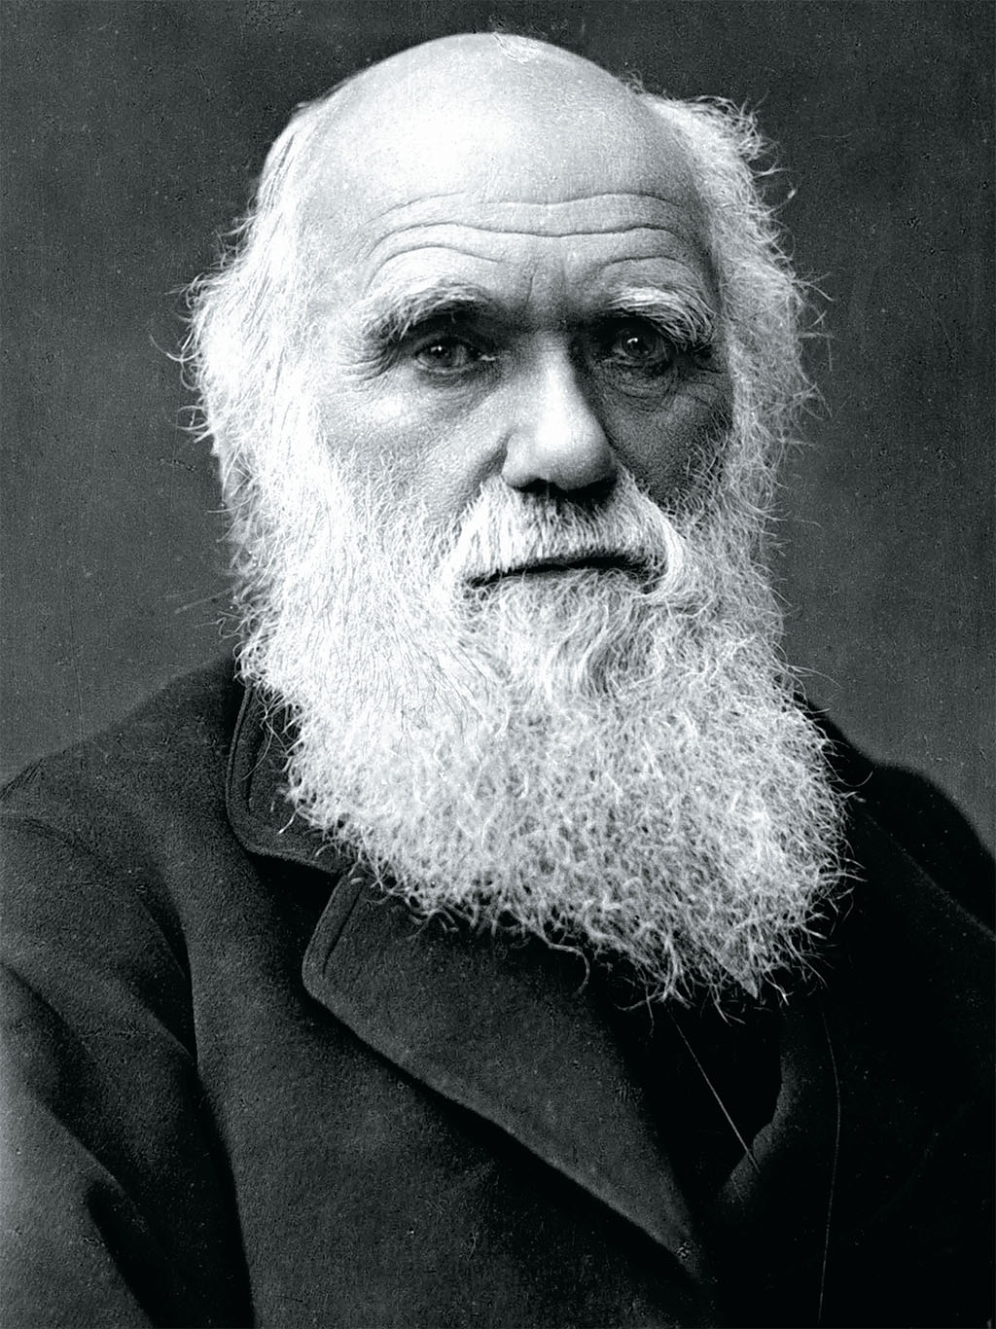

Key Knowledge
- To know that different kinds of rocks are grouped together on the basis of their appearance and simple physical properties
- Describe in simple terms how fossils are formed when things that have lived are trapped within rock
- To know and recognise that soils are made from rocks and organic matter.

