Knowledge Sheet History

The Stone Age Cycle B KS1

Intent

At Havannah Primary School our intention within History, is to develop within our pupils a deep sense of chronology and an appreciation of the significance of individuals within the shaping of our History.

Our curriculum will nurture a deep sense of inquisitiveness and ingenuity within our pupils and enable children to make connections and transfer skills and knowledge to a variety of learning opportunities. Our uniquely creative curriculum will inspire our pupils, stimulate their curiosity about the past and encourage investigation and critical thought.

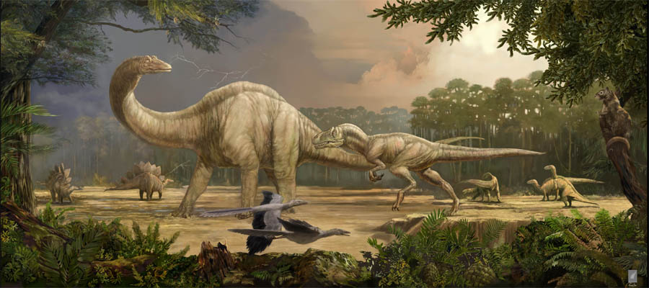 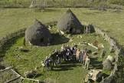 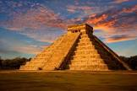 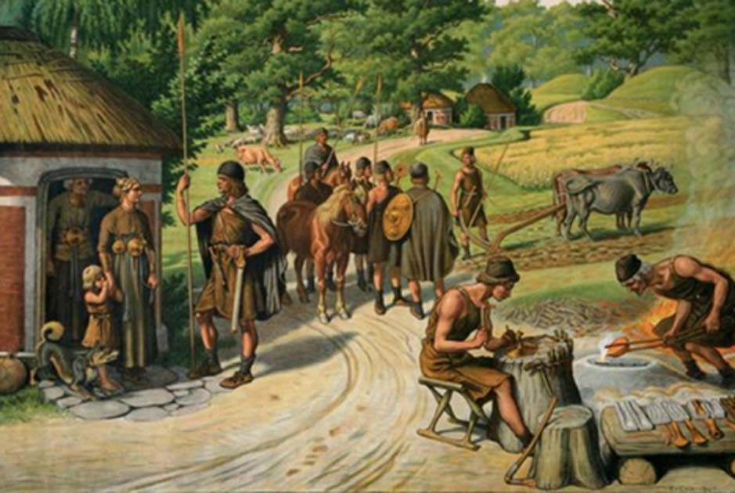

**Dinosaurs 252 MYA Stone Age 30,000 BC Mayans 2000 BC Bronze-Iron Age 2500BC**

**Timeline of Chronology**

Key Vocabulary

|  |  |
| --- | --- |
| Homo habilis | an early human who evolved around 2.3 million years ago, was probably the first to make stone tools. |
| BC/handaxe/flint blades | BC is a way of dating years before the birth of Jesus. |
| Evolution | A gradual process of change over time. |
| Hunter-gatherer | A member of normadic group who hunt or harvest food that grows in the wild. |
| Skara Brae | Stone Age village – 8 preserved houses made of stone. |
| Normadic people | A group of people that move from place to place in search of food and shelter |
| Cave paintings | Cave or rock paintings are painted on cave or rock walls and ceilings. |
| Round house | A type of circular house |
| Stone Henge | A prehistoric monument in Wiltshire |

Key Knowledge

* To compare aspects of life in the Stone Age.
* To ask and answer questions, choosing and using parts of stories and other sources to show they know and understand key periods in history.
* To investigate the key social developments within this period of history, for example tools, housing, farming, culture and art.
* Changes in Britain from Stone Age to Iron Age.
* To use a range of historical; Homo habilis, BC/handaxe/flint blades, evolution, hunter-gatherer, Skara Brae, normadic people, cave paintings, round houe, Stone Henge.
* To investigate Stone age hunting.
* To place developments and changes onto a timleline.

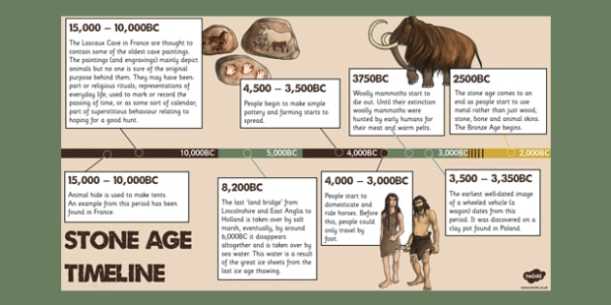

Key Questions

What was life like in the Stone Ages?

Which animals lived during the Stone Age and how were they hunted?

What was the most important Stone Age invention?

What was life like in a Stone Age settlement?