Daffodil Service!  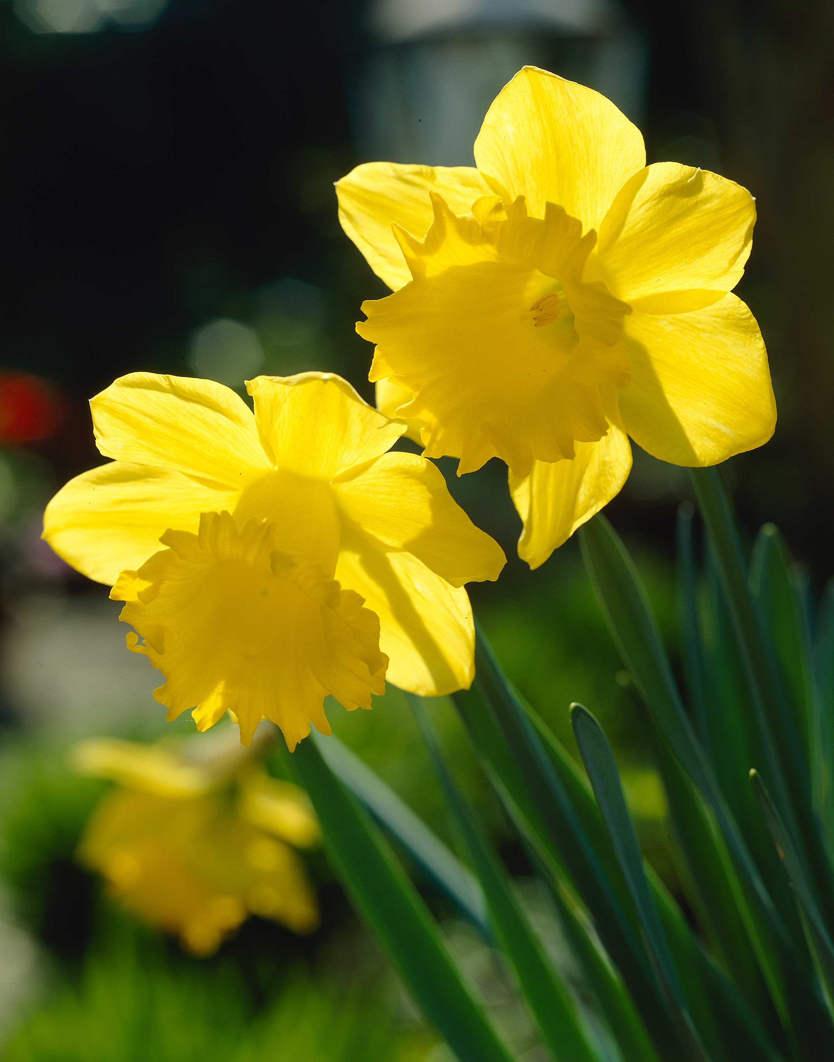  Spring 1  Year 2 | Assessment  Write the initials of the child next to each objective to show the level that they are working at.
Can I… | Working  Towards | Expected | Exceeding
- Perform and sing / play expressively and creatively to an audience
- Identify rhyming couplets in a song
- Understand the terms canon and unison
- To understand the term dynamics
- Play an untuned instrument to a piece of music in canon and unison
- Create a chant of 2 verses about daffodils (exploring rhyming couplets)

End Points – Spring 1 | Assessment  Write the initials of each child to show the level that they are working at.
 | Working Towards | Expected | Exceeding
Can I perform or play expressively and creatively to an audience?
Can I use music terminology to discuss a song?
Can I create a chant to show a theme whilst using features taught?

The 4 Elements of Success:
- Performing and Playing
- Listening and Evaluating
- Understanding and Exploring
- Create and Compose

Please write the initials of each child next to each objective to show what level they are working at for each objective. This is the same for the end points.

